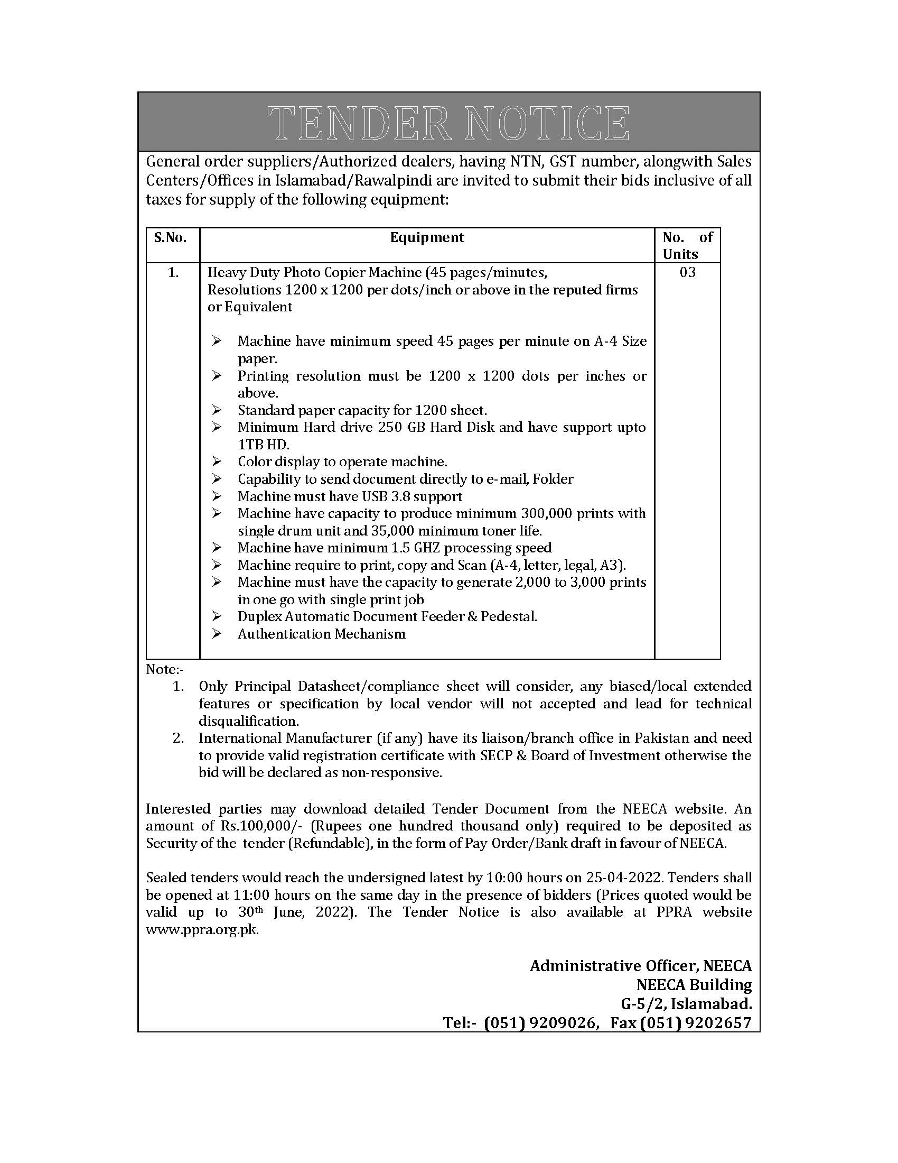

Government of Pakistan
Ministry of Energy (Power Division)
National Energy Efficiency and Conservation Authority (NEECA)

TERMS AND CONDITIONS OF TENDER

- Tender Format
Single stage two envelope bidding procedure under Rule 36 (b) of PPRA Rules 2004 will be adopted. Bids must be accompanied by a bank draft/pay order/call deposit from any schedule bank in favour of National Energy Efficiency and Conservation Authority (NEECA), as earnest money of Rs. 100,000/-. Bids received without earnest money will be rejected. Conditional bids will also be rejected.

Date and Time of Receipt of Tender
Bid documents duly completed should reach this office on or before 25-04-2022, 10:00 A
.M. on the tender closing date. Bids received after the closing date and time will not be entertained. No telegraphic or faxed bid will be accepted. Bids shall be opened on the same date at 11:00 A.M. in presence of bidders or their authorized representatives in the Committee Room, NEECA Building, Sector G-5/2, Islamabad.

Earnest Money
The bidder will attach bank draft/pay order/call deposit from any schedule bank of Rs. 100,000/-, in favour of National Energy Efficiency and Conservation Authority (NEECA), refundable on satisfactory completion of warranty period of equipment. Cheques will not be acceptable. Bids without valid earnest money shall not be entertained.

Prices
  - Bidders will be required to quote on (Standard Bidding Document) all prices ex-Islamabad in Pak Rupees inclusive of government taxes, charges, octroi, GST, transportation etc. and at specified site in Islamabad. Items should be duties and tax paid.
  - The quotation should remain valid for at least 90 days from the date of opening the bid.

Technical Documents
  - All information provided in bid should also be adequately supported by relevant documents and technical brochures. Bidder may attach documents that highlight the competitive edge and unique features of their proposal.

  - Manufacturer’s Authorization Letter is to be submitted along with the tender.
  - Any specification or condition mentioned in tender document, if not found in bid document, shall give right to National Energy Efficiency and Conservation Authority (NEECA) to consider it as “condition not being met/fulfilled”.

Equipment
- The equipment delivered should be new and in no case used or refurbished. The component of the equipment should be assembled by the manufacturer.
- The equipment should be arranged through legal channels by providing all duties/taxes (if any) levied the government and towards this end, copies of the shipping documents will need to be deposited in NEECA.
- The successful bidder shall submit original Bill of Entry and Packing list at time of delivery of equipment.

Office/Service Centre in Islamabad
The bidding firm having valid NTN and duly registered with FBR for Sales Tax must have proper office/service support centre in Islamabad.

Delivery Period
The supplier will be required (DDP) delivery of equipment at customer’s premises within
One month from the date of issue of Purchase Order.

Warranty
01 Year comprehensive warranty for Laptops and Heavy Duty Photo Copier Machine from authorized manufacturer/ OEM dealer in Pakistan should be clearly specified.

Evaluation Criteria
Contract will be awarded on the basis of item-wise lowest cost to the party which meet specifications given in the bidding proforma, instructions mentioned in this tender document and the advertisement.

Schedule of Payment
No advance payment shall be made against the purchase of equipment. Bills of payment shall be submitted to NEECA after delivery of equipment on site with necessary installation & configuration where required.

Disqualifications
Offers are liable to be rejected if, there is any deviation from the instructions as laid down in the bid document i.e.
- Technical details/brochures and literature pertaining to the offered items are not attached.
- Tenders are submitted without the required earnest money.
- Bids/Tenders are received after specified date and time of receipt.
- Specifications and other requirements are not properly adhered to or manufacturer’s brochure shows specifications different from those given in tender.
- GST/NTN certificate is not attached.
- Shipping/documents demonstrating that the equipment arranged through legal channels.
- Service centre is not in Islamabad and service response time exceeds 24 hours.
- Any other major discrepancy found in the proposal.

Clarifications required if any
If further clarification is required regarding this tender, the intended bidder is advised to contact in writing to Director General (HR & SS), National Energy Efficiency and Conservation Authority (NEECA), NEECA Building, Sector G-5/2, Islamabad. The response to clarification will be sent to the bidder.

Rights reserved
National Energy Efficiency and Conservation Authority (NEECA) reserves the right to accept or reject any or all the bids under provisions of Rule 33 of PPRA Rules 2004. NEECA also reserves the right to increase/decrease the quantity of equipment or may withdraw the tender without assigning any reason thereof.

Item: Heavy Duty B & W Photocopier

Detailed specification | Conformation to the specification
 | Yes | No
Heavy Duty Photo Copier Machine (45 pages/minutes,
Resolutions 1200 x 1200 per dots/inch or above in the reputed firms or Equivalent
- Machine have minimum speed 45 pages per minute on A-4 Size paper.
- Printing resolution must be 1200 x 1200 dots per inches or above..
- Minimum Hard drive 250 GB Hard Disk and have support upto
1TB HD
- Color display to operate machine..
- Capability to send document directly to e-mail, Folder
- Machine must have USB 3.8 support
- Machine have capacity to produce minimum 300,000 prints with single drum unit and 35,000 minimum toner life..
- Machine have minimum 1.5 GHZ processing speed
- Machine require to print, copy and Scan (A-4, letter, legal, A3).
- Machine must have the capacity to generate 2,000 to 3,000 prints in one go with single print job
- Duplex Automatic Document Feeder & Pedestal
- Authentication Mechanism

Note:-
1- Only Principal Datasheet/ compliance sheet will consider, Any biased / local extended features or specification by local vendor will not accepted and lead for technical disqualification.
2- If any international Manufacturer have its liaison/branch office in Pakistan than they needs to provide valid registration certificate with SECP & Board of Investment else bid will declare non-responsive.

Rate quoted per unit  (Including taxes) | Quantity | Total Amount  (in Pak Rupees)
 | 03

